# ArgoCD integration with AWS SSO:

**Pre-requisites:**

* Requires an AWS account
* Requires ArgoCD setup

**Steps to create custom application in AWS SSO IAM Identity Center**

1. Navigate to the IAM Identity Center > choose applications under the application assignment.

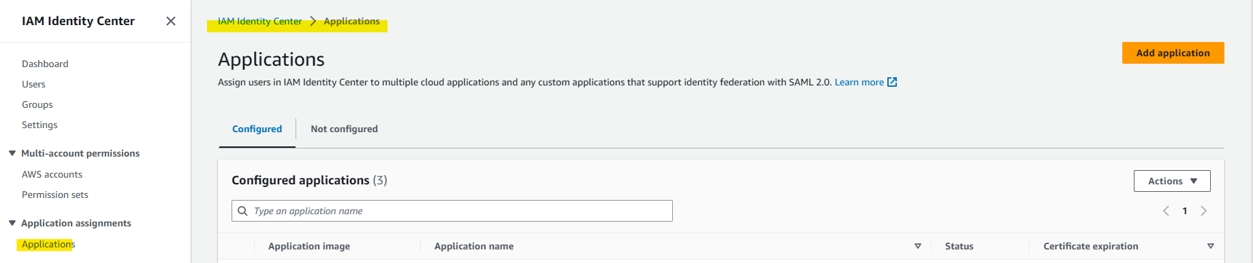

1. Create the application and choose the add custom SAML 2.0 application. As there is no preintegrated application for the ArgoCD.

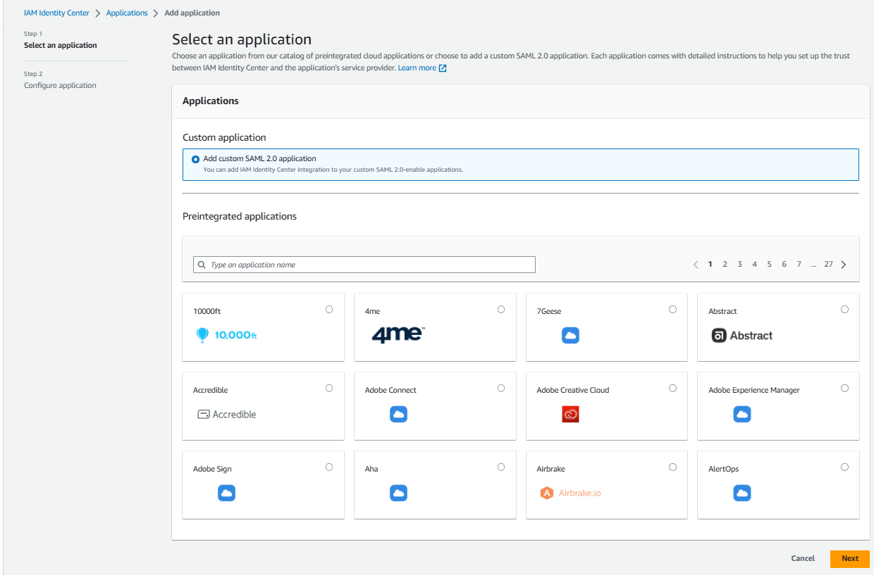

1. Provide the display name and Description.

* Download the IAM identity center certificate later it is required to configure in the Argocd config map.
* Copy the IAM Identity Center sign-in URL
* Copy IAM Identity Center SAML issuer URL

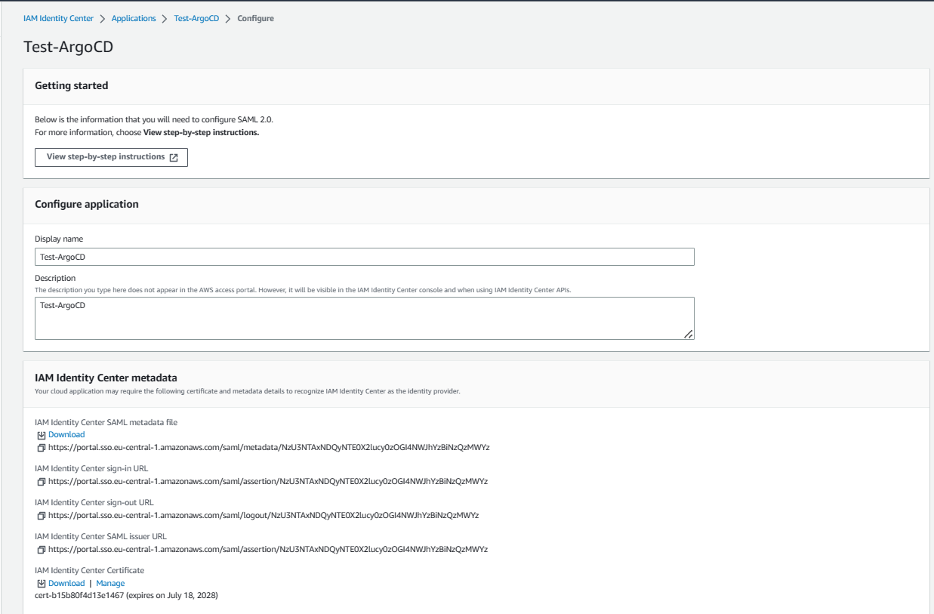

1. As the application properties is optional skip that filed and configure the application metadata and submit.

* Provide the Application ACS URL and Application SAML audience.

**Example:** https://<argocd URL> /api/dex/callback.

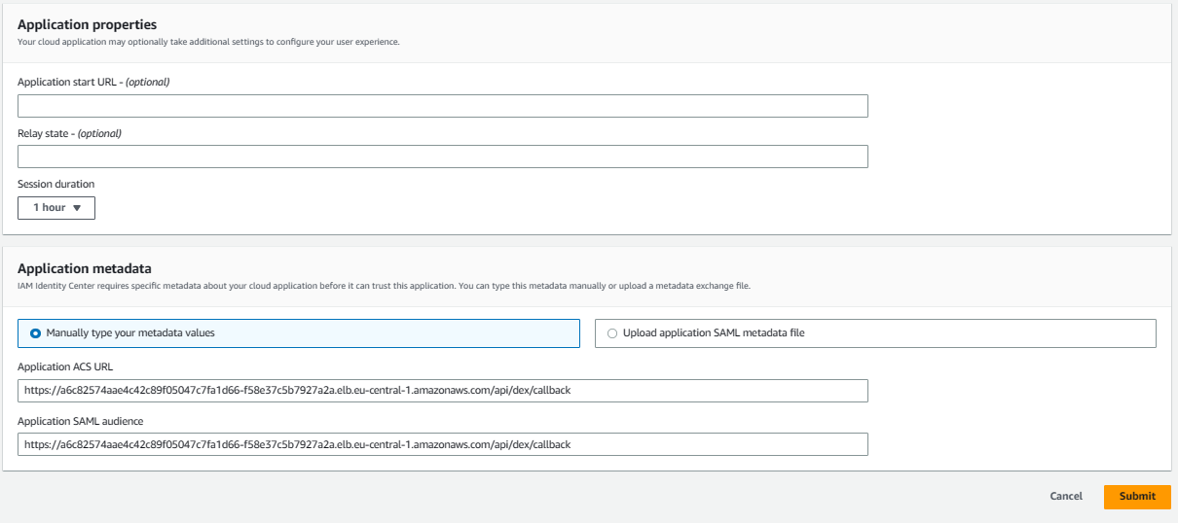

1. Create the user and assign it to the application.

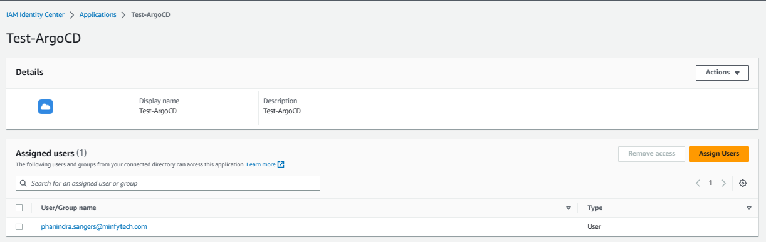

1. Edit the attribute mappings values.

* ${user:name}
* ${user:email}

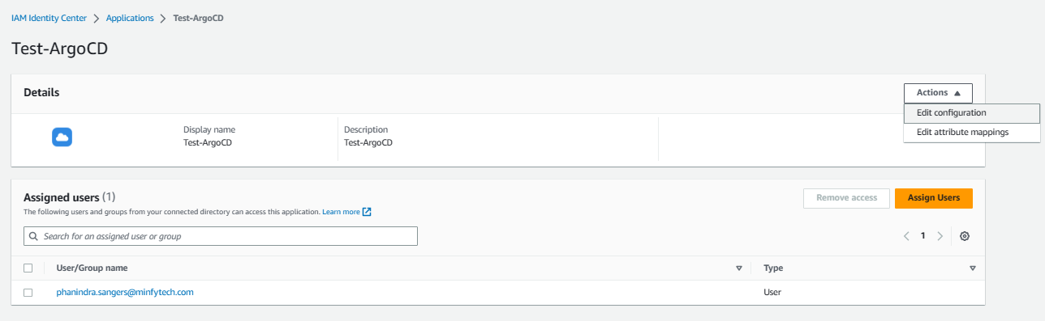

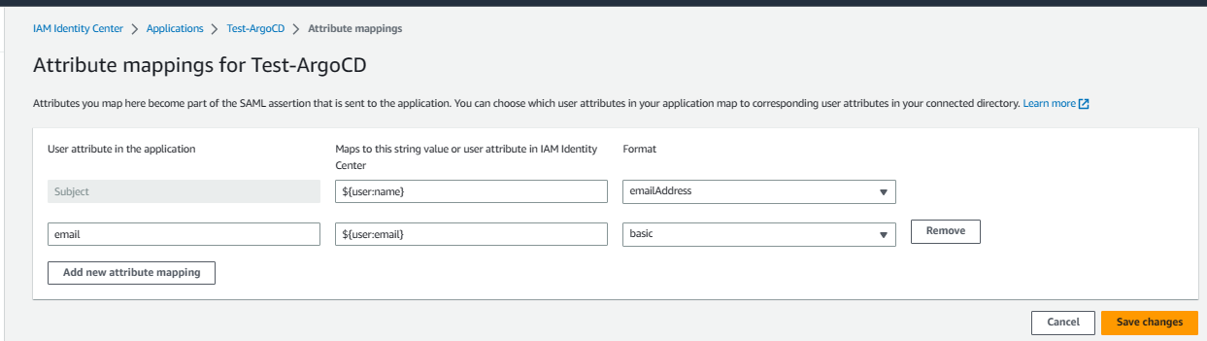

**Steps to configure in the ArgoCD config map file.**

Below is the configuration template need to be update in the argocd cm.

1. Provide the below details.

* SSO URL: provide the SSO URL as the IAM Identity Center sign-in URL which is copied in the previous step.
* caData: Provide the certificate in the Base6 encoded format.

data:

url: https://<argocd-url>/

dex.config: |

logger:

level: debug

format: json

connectors:

- type: saml

id: saml

name: saml

config:

entityIssuer: https://<argocd-url>/api/dex/callback

ssoURL: https://login.microsoftonline.com/11a1111a-1111-111a-111b-11c1d111e1f1/saml2

caData: |

BASE64 ENCODED CRT

redirectURI: https://<argocd-url>/api/dex/callback

usernameAttr: email

emailAttr: email

groupsAttr: Group

Below the screenshot for your reference.

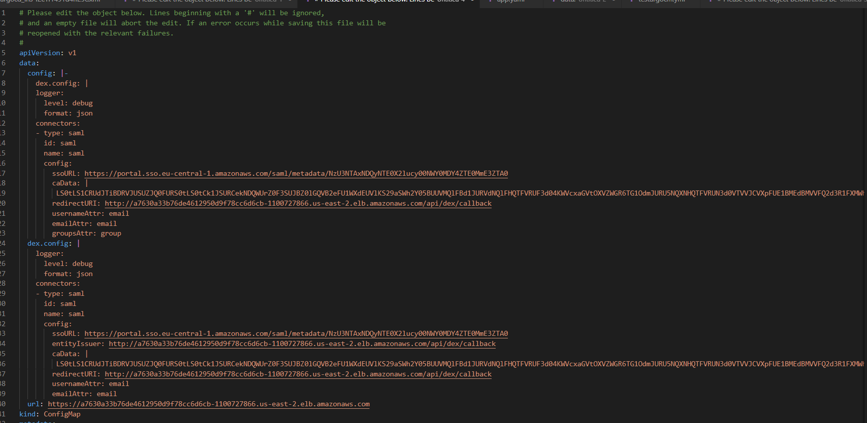

1. Login into the AWS console by providing the Username and password.
2. Below is the sceenshot post login into the AWS console and will be able to see the application which is created.

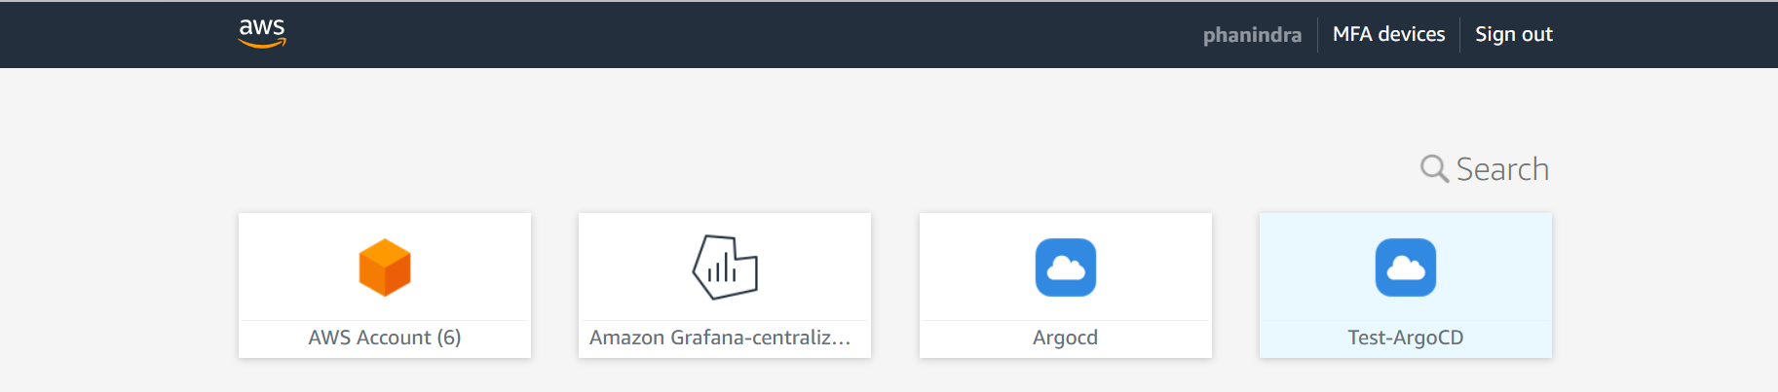

1. Click on the Test ArgoCD which redirect to the application.

Below is the error we are facing while accessing the application.

